Low-Level Design (LLD) — Complaint Entry & Assign Process
Attribute | Value
Document focus | Complaint Entry (create) + Assign process only
Module | Complaint Entry
Menu path | SUPPORT → Complaint Entry
Landing page | new_complaint.php
Assign page | assign_complaint.php
Stack (target) | Core PHP + MySQL (PDO)
Stack (current repo) | Core PHP + PostgreSQL via PDO
Document version | 1.0

Out of scope for this document: Closure, Re-Open, Soft-delete, Assigned Complaint List, Service Update, Service Log / Installed Base.
â”€â”€â”€â”€â”€â”€â”€â”€â”€â”€â”€â”€â”€â”€â”€â”€â”€â”€â”€â”€â”€â”€â”€â”€â”€â”€â”€â”€â”€â”€â”€â”€

1. Module Overview

1.1 Purpose
Authorized users register a complaint against a Fab Number (must exist in LN invoice data), capture customer and address details, select a complaint category and description, and optionally assign an ELGi Engineer at create time. Open complaints can later be assigned from Complaint History via the Assign modal.

1.2 Scope
In scope | Out of scope
Create complaint (POST submit_complaint) | Closure / Re-Open / Resolve
Optional assign at create | Soft-delete
Manual assign for Open complaints | Service Update / HO approval
Complaint History listing (view context) | Editing core complaint fields after create
FAB + pincode prefill | Order / dealer fields

1.3 High-level architecture
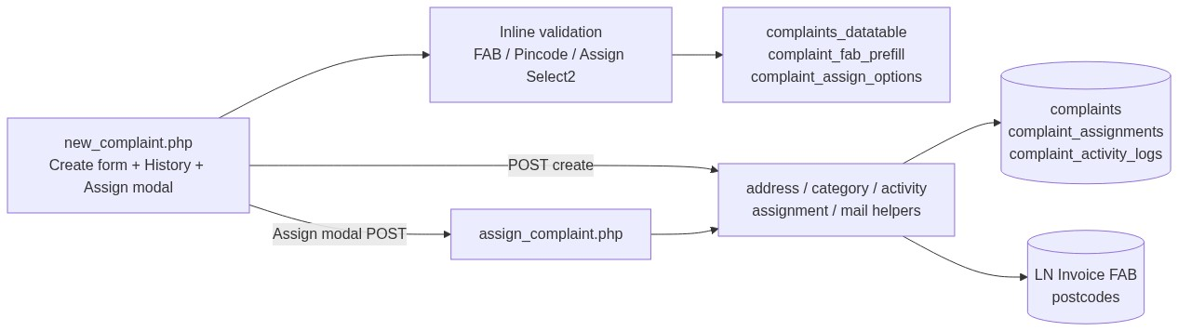
Figure 1 â€” High-level architecture
â”€â”€â”€â”€â”€â”€â”€â”€â”€â”€â”€â”€â”€â”€â”€â”€â”€â”€â”€â”€â”€â”€â”€â”€â”€â”€â”€â”€â”€â”€â”€â”€

2. Functional Requirements
ID | Requirement | Priority
FR-01 | Users with view can open Complaint Entry and history | Must
FR-02 | Users with add can create a complaint | Must
FR-03 | FAB must exist in LN invoice data | Must
FR-04 | Address required; city/district/state from pincode | Must
FR-05 | Complaint category and description required | Must
FR-06 | Optional Assign To at create if user has assign-complaint | Must
FR-07 | Create without assignee → status Open (1) | Must
FR-08 | Create with assignee → status In Progress (2) + assignment row | Must
FR-09 | Manual assign from history only when status is Open | Must
FR-10 | Assignee must be an active ELGi Engineer (role filter) | Must
FR-11 | Dealer creator may assign only to self | Must
FR-12 | Assignment creates activity log + notification email | Should
FR-13 | FAB prefill from prior complaint under list scope | Should

â”€â”€â”€â”€â”€â”€â”€â”€â”€â”€â”€â”€â”€â”€â”€â”€â”€â”€â”€â”€â”€â”€â”€â”€â”€â”€â”€â”€â”€â”€â”€â”€

3. User Roles & Permissions

3.1 RBAC module slug
complaint-entry

3.2 Permission matrix (Entry + Assign only)
Permission slug | Capability
view | Entry page, history, details (from=entry)
add | Create complaint; FAB prefill API
assign-complaint | Assign at create and Assign modal

3.3 Page / API mapping
Resource | Permission / gate
new_complaint.php | view
complaint_details.php (from=entry) | view
api/complaints_datatable.php | view
api/complaint_fab_prefill.php | add
assign_complaint.php | assign-complaint
api/complaint_assign_options.php | assign / related permissions
api/postcode_search.php | Session
api/ln_invoice_fabno_search.php | Session

3.4 List scope (history)
Role class | Sees
System Admin / Management / CCS Admin | All non-deleted
Sales Coordinator | Scoped creators / assignees
Other | Own created (username) or assigned to self

â”€â”€â”€â”€â”€â”€â”€â”€â”€â”€â”€â”€â”€â”€â”€â”€â”€â”€â”€â”€â”€â”€â”€â”€â”€â”€â”€â”€â”€â”€â”€â”€

4. Business Rules
ID | Rule
BR-01 | Soft-deleted rows excluded from history (deleted_at IS NULL).
BR-02 | Create without assignee → status = 1 (Open).
BR-03 | Create with assignee → status = 2 (In Progress) + complaint_assignments insert.
BR-04 | Manual assign only when current status is Open.
BR-05 | Manual assign sets status to In Progress.
BR-06 | FAB must exist in LN invoice (ln_invoice_fabno_exists).
BR-07 | Category must be an active complaint_categories row.
BR-08 | Customer name: alphabetic characters and spaces only.
BR-09 | Assignment remarks max 500 characters.
BR-10 | Assignee Select2 value = user_master.name; resolved to assigned_to user id.
BR-11 | Dealer user creating a complaint may only assign to self.
BR-12 | Assignee must pass complaint_validate_elgi_engineer_assignee (active engineer role).
BR-13 | Activity types for this process: Created, Assignment.
BR-14 | No post-create edit of core complaint master fields.

â”€â”€â”€â”€â”€â”€â”€â”€â”€â”€â”€â”€â”€â”€â”€â”€â”€â”€â”€â”€â”€â”€â”€â”€â”€â”€â”€â”€â”€â”€â”€â”€

5. Database Design

5.1 ER diagram (Entry + Assign)
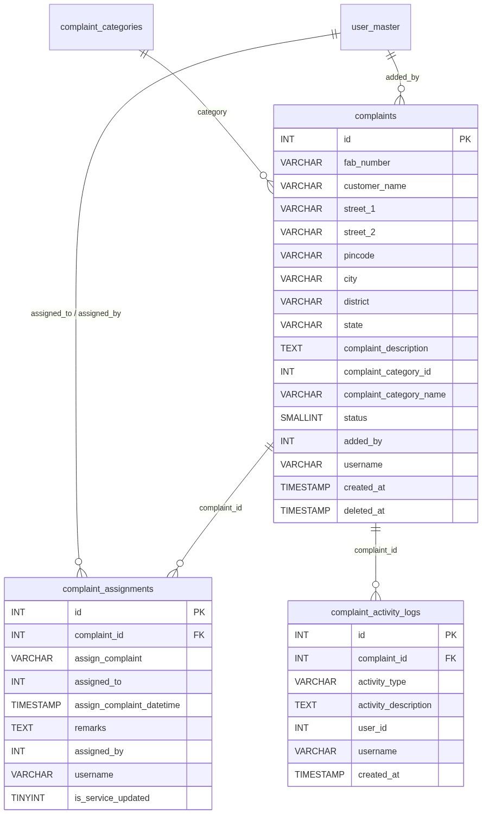
Figure 2 â€” Entity relationship diagram

5.2 Table: complaints (create columns)
Column | MySQL type | Notes
id | INT UNSIGNED AUTO_INCREMENT | PK
fab_number | VARCHAR(100) | LN FAB
customer_name | VARCHAR(255)
street_1 / street_2 | VARCHAR(255)
pincode | VARCHAR(10) | 6-digit
city / district / state | VARCHAR(100) | From postcodes
complaint_description | TEXT
complaint_category_id | INT UNSIGNED
complaint_category_name | VARCHAR(100) | Snapshot
status | SMALLINT | 1 Open / 2 In Progress on this flow
added_by | INT UNSIGNED | Creator
username | VARCHAR(100) | Creator username
created_at | TIMESTAMP | Default now
deleted_at | TIMESTAMP NULL | Soft-delete (not used in this process write path)

5.3 Related tables
Table | Role in Entry + Assign
complaint_assignments | One row per assign (create-time or manual)
complaint_activity_logs | Created / Assignment
complaint_categories | Category Select2
postcodes | Pincode autofill
LN invoice ($dpconn) | FAB existence

5.4 Reference / lookup sources
Source | Usage
api/ln_invoice_fabno_search.php | FAB Select2
api/complaint_fab_prefill.php | Prior complaint address by FAB
api/postcode_search.php | Pincode → city/district/state
complaint_categories | Category options
api/complaint_assign_options.php | Assignee options

â”€â”€â”€â”€â”€â”€â”€â”€â”€â”€â”€â”€â”€â”€â”€â”€â”€â”€â”€â”€â”€â”€â”€â”€â”€â”€â”€â”€â”€â”€â”€â”€

6. API / Backend Design

6.1 Page endpoints
Endpoint | Method | Auth | Description
new_complaint.php | GET | view | Form + history
new_complaint.php | POST submit_complaint | add (+ assign-complaint if assignee set) | Create (± assign)
assign_complaint.php | POST | assign-complaint | Manual assign Open → In Progress
complaint_details.php?from=entry | GET | view | Read-only details

6.2 JSON APIs
API | Purpose
POST api/complaints_datatable.php | Complaint History
GET api/complaint_fab_prefill.php?fab_number= | Prefill customer/address
api/complaint_assign_options.php | Dynamic assignees for modal

6.3 Supporting lookup APIs
API | Purpose
api/postcode_search.php | Pincode Select2
api/ln_invoice_fabno_search.php | FAB Select2

6.4 Core PHP responsibilities
File / area | Role
new_complaint.php | Create orchestration
assign_complaint.php | Manual assign orchestration
complaint_address_helpers.php | Address validate
complaint_category_helpers.php | Category resolve
complaint_activity_helpers.php | Activity insert
complaint_assignment_helpers.php | Assignee validate / resolve / options
complaint_assignment_mail_helpers.php | Assignment email
ln_invoice_helpers.php | FAB exists

â”€â”€â”€â”€â”€â”€â”€â”€â”€â”€â”€â”€â”€â”€â”€â”€â”€â”€â”€â”€â”€â”€â”€â”€â”€â”€â”€â”€â”€â”€â”€â”€

7. Validation Rules

7.1 Server-side — Create
Rule | Message
No add | Access denied. You do not have permission to add complaints.
Assignee set without assign-complaint | Access denied. You do not have permission to assign complaints.
Address | Street/Pincode/City/District/State required + length/format rules
FAB empty | Fab Number is required.
FAB not in LN | Selected Fab Number was not found in invoice details.
Customer | Required; alphabetic + spaces only
Category | Complaint Category is required.
Remarks | Remarks cannot exceed 500 characters.
Dealer self-only | Selected Dealer User is not allowed for this complaint.
Engineer check | Selected assignee must be an active ELGi Engineer.
Persist | Failed to submit complaint.

7.1b Server-side — Manual Assign
Rule | Message
Missing id / assignee | Redirect / assign required
Not Open | Manual assign is only allowed for open complaints.
Outside access | Access denied. You do not have permission to assign this complaint.
Invalid engineer | Selected assignee must be an active ELGi Engineer.
Persist | Failed to assign complaint.
Missing user | Unable to resolve logged-in user.

7.2 Client-side
Form | Rules
Create (inline on new_complaint.php) | FAB, customer, street, pincode, city/district/state, description, category, remarks ≤ 500
Assign modal | Engineer required; remarks ≤ 500

â”€â”€â”€â”€â”€â”€â”€â”€â”€â”€â”€â”€â”€â”€â”€â”€â”€â”€â”€â”€â”€â”€â”€â”€â”€â”€â”€â”€â”€â”€â”€â”€

8. UI Screen Specifications

8.1 Listing — Complaint History
Status cards + DataTable: ID, Fab, Customer, Category, Address, optional Added By, Status, Created At, Action.
Assign action shown for Open complaints when user has assign-complaint.

8.2 Form panel — New Complaint
1. Customer Information — Fab*, Customer*, Street 1*, Street 2, Pincode*, City/District/State*
2. Complaint Details — Category*, Description*
3. Assignment (if assign-complaint) — Assign To, Remarks
Submit: Submit Complaint

8.3 Details
complaint_details.php?from=entry — read-only (view after create/assign).

8.4 Modals
Modal | When | Fields
Assign | Open row + assign-complaint | Assign To*, Remarks

â”€â”€â”€â”€â”€â”€â”€â”€â”€â”€â”€â”€â”€â”€â”€â”€â”€â”€â”€â”€â”€â”€â”€â”€â”€â”€â”€â”€â”€â”€â”€â”€

9. Database Flow

9.1 Create (± assign at create)
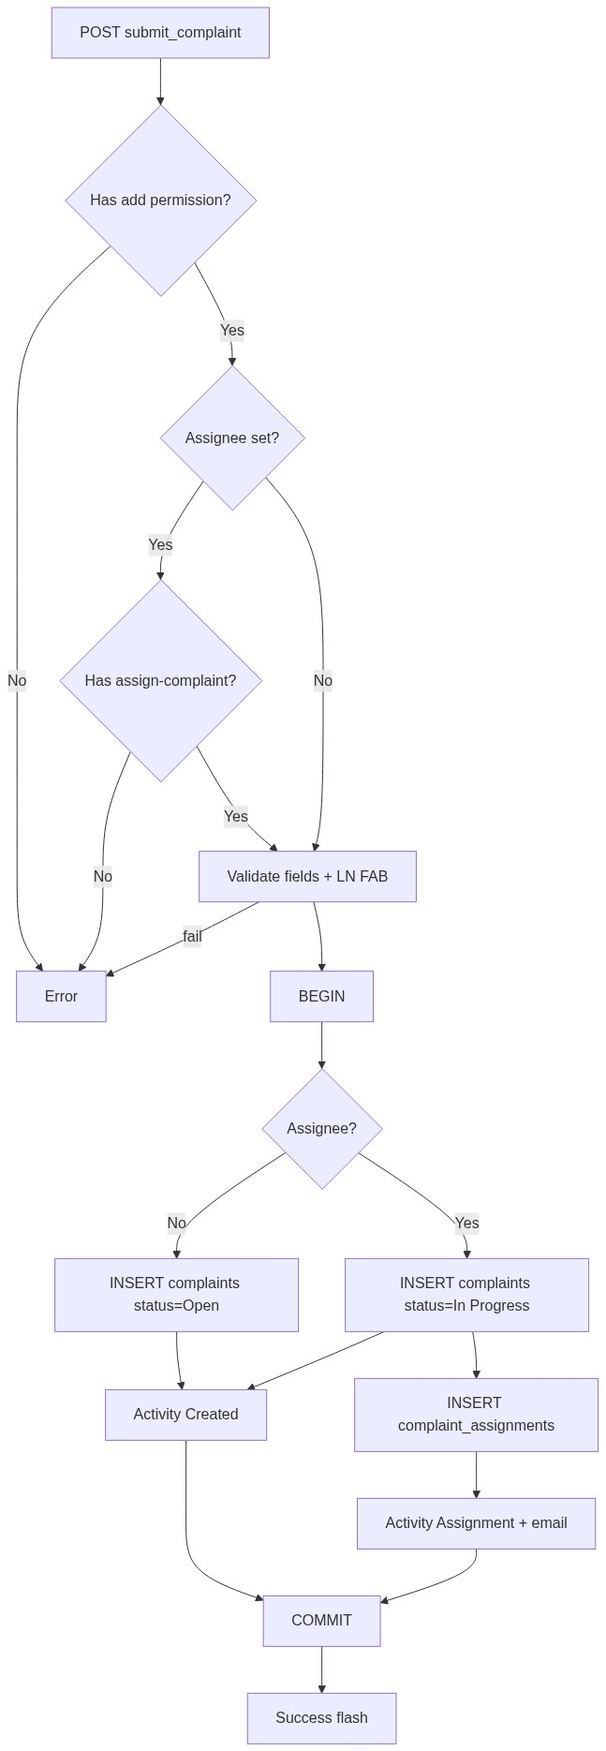
Figure 3 â€” Create database flow

9.2 Soft-delete
Not part of this document.

9.3 List query pattern
SELECT ... FROM complaints
WHERE deleted_at IS NULL
AND /* complaint_entry_list_scope */
AND /* optional status_filter / search */
ORDER BY created_at DESC
LIMIT :limit OFFSET :offset;
â”€â”€â”€â”€â”€â”€â”€â”€â”€â”€â”€â”€â”€â”€â”€â”€â”€â”€â”€â”€â”€â”€â”€â”€â”€â”€â”€â”€â”€â”€â”€â”€

10. Sequence Diagram

10.1 Create complaint (optional assign)
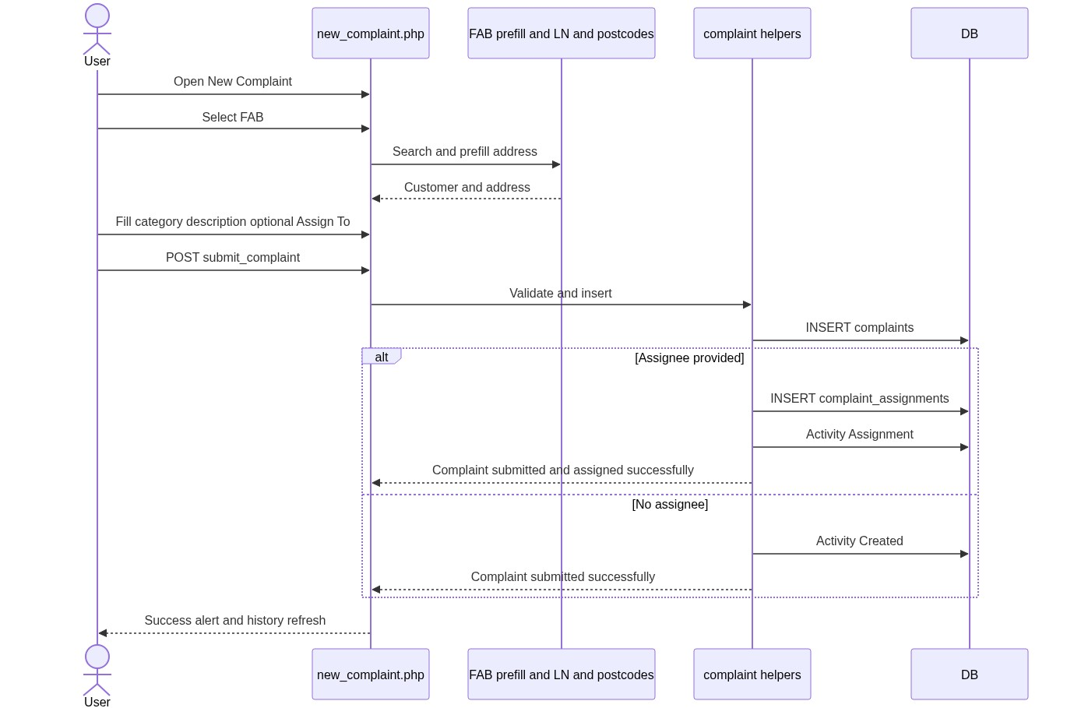
Figure 4 â€” Sequence: Create / update on Spare Parts page

10.2 Manual assign from history
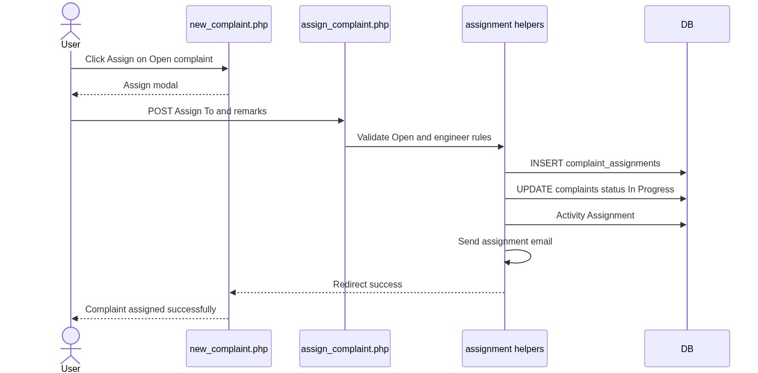
Figure 5 â€” Sequence: Add Spare Parts from IB / SL row
â”€â”€â”€â”€â”€â”€â”€â”€â”€â”€â”€â”€â”€â”€â”€â”€â”€â”€â”€â”€â”€â”€â”€â”€â”€â”€â”€â”€â”€â”€â”€â”€

11. Activity Diagram
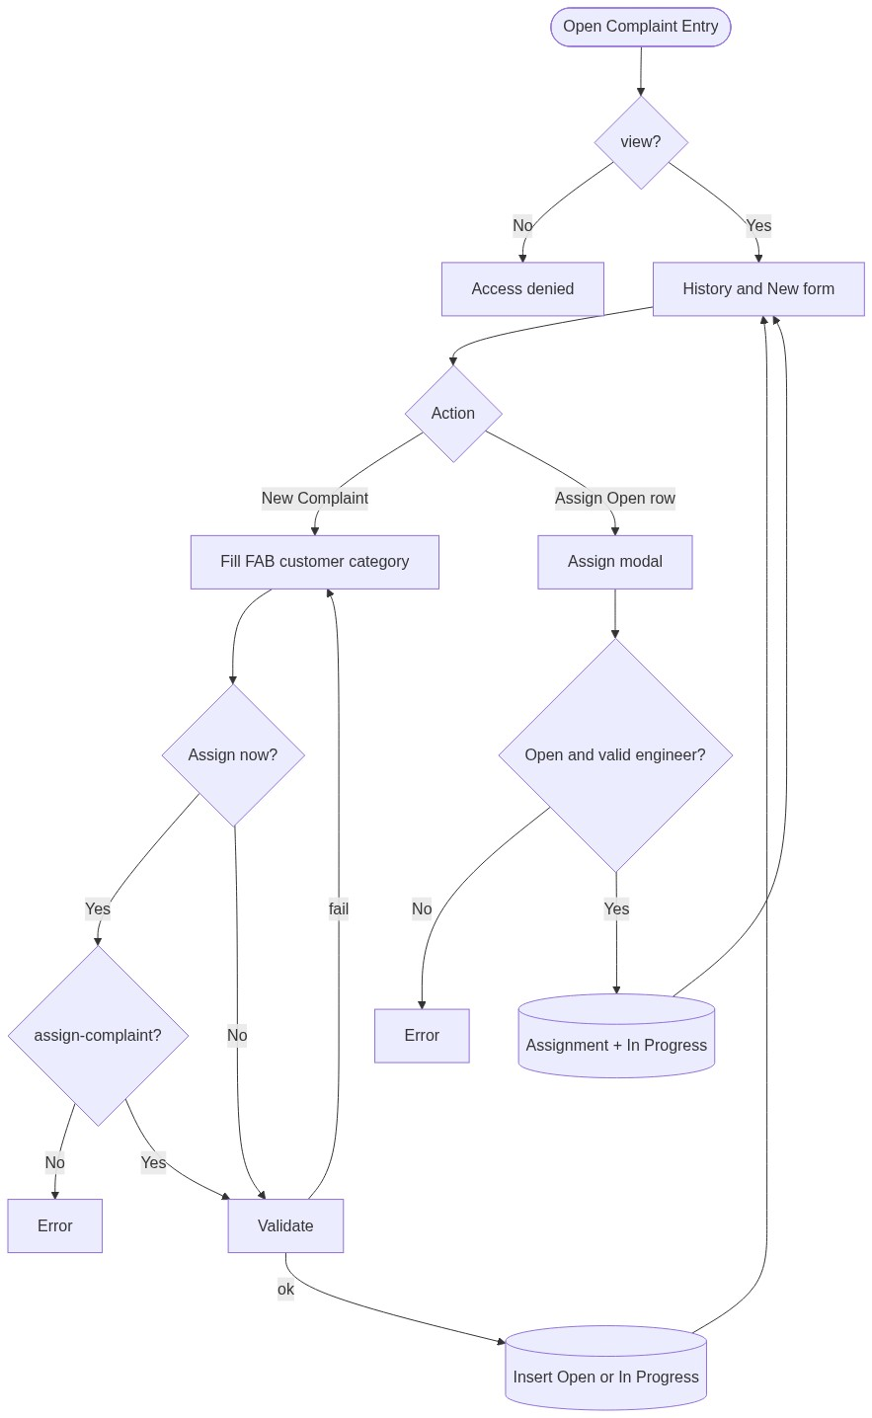
Figure 6 â€” Activity diagram
â”€â”€â”€â”€â”€â”€â”€â”€â”€â”€â”€â”€â”€â”€â”€â”€â”€â”€â”€â”€â”€â”€â”€â”€â”€â”€â”€â”€â”€â”€â”€â”€

12. Class / Module Diagram
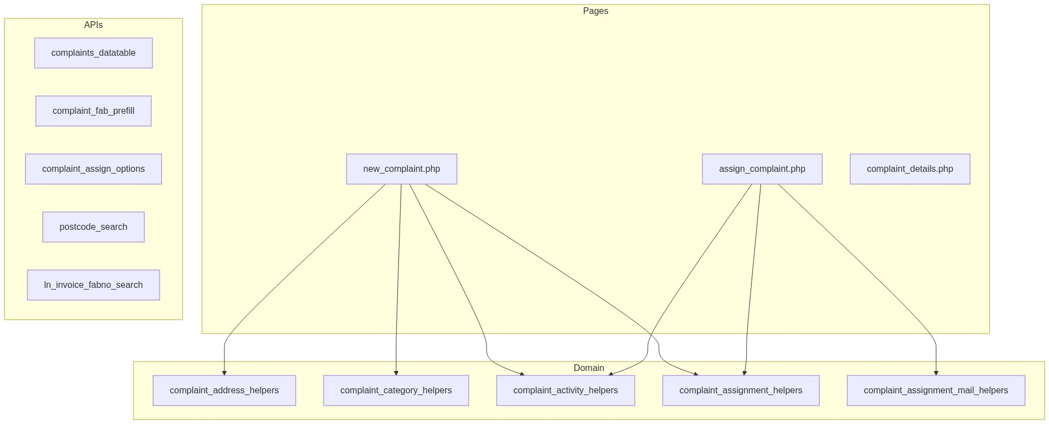
Figure 7 â€” Class / module diagram

12.1 Key functions
Function / area | Role
Address helpers | Validate street/pincode/city
Category helpers | Active category + name snapshot
complaint_activity_insert (helpers) | Created / Assignment
complaint_resolve_assignee_user_id | Name → user id
complaint_validate_elgi_engineer_assignee | Engineer role check
complaint_validate_assignee_for_complaint | Dealer/self and access rules
complaint_assign_options_for_current_creator | Create-form assignee list
complaint_assignment_notify_email | Email on assign

â”€â”€â”€â”€â”€â”€â”€â”€â”€â”€â”€â”€â”€â”€â”€â”€â”€â”€â”€â”€â”€â”€â”€â”€â”€â”€â”€â”€â”€â”€â”€â”€

13. Folder Structure
ComplaintManagement/
├── new_complaint.php
├── assign_complaint.php
├── complaint_details.php
├── api/
│ ├── complaints_datatable.php
│ ├── complaint_fab_prefill.php
│ ├── complaint_assign_options.php
│ ├── postcode_search.php
│ └── ln_invoice_fabno_search.php
├── includes/
│ ├── complaint_address_helpers.php
│ ├── complaint_category_helpers.php
│ ├── complaint_activity_helpers.php
│ ├── complaint_assignment_helpers.php
│ ├── complaint_assignment_mail_helpers.php
│ └── ln_invoice_helpers.php
└── js/
├── complaint_fab_prefill.js
├── fabno_select2.js
├── pincode_select2.js
├── assign_to_select2.js
└── static_select2.js
â”€â”€â”€â”€â”€â”€â”€â”€â”€â”€â”€â”€â”€â”€â”€â”€â”€â”€â”€â”€â”€â”€â”€â”€â”€â”€â”€â”€â”€â”€â”€â”€

14. Error Handling
Layer | Pattern
Create POST | In-page $error_message / $success_message
Assign POST | Session flash + redirect new_complaint.php
APIs | JSON { "error": "..." }

14.1 Common messages
Message | When
Complaint submitted successfully. | Create unassigned
Complaint submitted and assigned successfully. | Create + assign
Complaint assigned successfully. | Manual assign
Access denied. You do not have permission to add complaints. | No add
Access denied. You do not have permission to assign complaints. | No assign on create
Selected Fab Number was not found in invoice details. | LN miss
Manual assign is only allowed for open complaints. | Wrong status
Failed to submit complaint. / Failed to assign complaint. | Persist fail

â”€â”€â”€â”€â”€â”€â”€â”€â”€â”€â”€â”€â”€â”€â”€â”€â”€â”€â”€â”€â”€â”€â”€â”€â”€â”€â”€â”€â”€â”€â”€â”€

15. Security Considerations
Area | Control
SQL Injection | PDO prepared statements
XSS | Escaped output
CSRF | Session POST; recommend CSRF tokens
AuthN / AuthZ | Session + RBAC (view / add / assign-complaint)
FAB integrity | Must exist in LN invoice
Assignee integrity | Engineer role + dealer self-assign rules
IDOR | Assign checks complaint access + Open status

â”€â”€â”€â”€â”€â”€â”€â”€â”€â”€â”€â”€â”€â”€â”€â”€â”€â”€â”€â”€â”€â”€â”€â”€â”€â”€â”€â”€â”€â”€â”€â”€

16. Audit Logs

16.1 Built-in field-level audit
Entity | Fields
complaints | added_by, username, created_at
complaint_assignments | assigned_by, username, created_at, assign_complaint_datetime
complaint_activity_logs | Created / Assignment with user_id, username, created_at

â”€â”€â”€â”€â”€â”€â”€â”€â”€â”€â”€â”€â”€â”€â”€â”€â”€â”€â”€â”€â”€â”€â”€â”€â”€â”€â”€â”€â”€â”€â”€â”€

17. Test Cases

17.1 Functional
ID | Scenario | Expected
TC-01 | Create without Assign To | Open; success “submitted”
TC-02 | Create with Assign To | In Progress; assignment row; email; “submitted and assigned”
TC-03 | Create with Assign To but no assign permission | Denied
TC-04 | FAB not in LN | Invoice error
TC-05 | Invalid customer / pincode / category | Validation errors
TC-06 | FAB prefill | Address populated
TC-07 | Assign Open complaint | In Progress; success
TC-08 | Assign In Progress / other status | Rejected Open-only
TC-09 | Dealer assigns someone else | Rejected
TC-10 | Non-engineer assignee | Rejected
TC-11 | History scope for normal user | Own / assigned only

â”€â”€â”€â”€â”€â”€â”€â”€â”€â”€â”€â”€â”€â”€â”€â”€â”€â”€â”€â”€â”€â”€â”€â”€â”€â”€â”€â”€â”€â”€â”€â”€

18. Assumptions & Dependencies

18.1 Assumptions
1. Portal session and user_master are available.
2. RBAC complaint-entry permissions (view, add, assign-complaint) are seeded.
3. LN FAB master and postcodes / complaint_categories are maintained.
4. Assignment email transport is configured.

18.2 Dependencies
Dependency | Purpose
LN invoice helpers | FAB validation
postcodes | Address autofill
Complaint categories | Category Select2
Assignment mail helpers | Notify assignee
jQuery + Select2 + DataTables + validate.js | UI

â”€â”€â”€â”€â”€â”€â”€â”€â”€â”€â”€â”€â”€â”€â”€â”€â”€â”€â”€â”€â”€â”€â”€â”€â”€â”€â”€â”€â”€â”€â”€â”€

Appendix A — Success messages
Event | Message
Create unassigned | Complaint submitted successfully.
Create + assign | Complaint submitted and assigned successfully.
Manual assign | Complaint assigned successfully.

â”€â”€â”€â”€â”€â”€â”€â”€â”€â”€â”€â”€â”€â”€â”€â”€â”€â”€â”€â”€â”€â”€â”€â”€â”€â”€â”€â”€â”€â”€â”€â”€

Appendix B — Select2 control map
Control | API / mode
Fab Number | api/ln_invoice_fabno_search.php (+ prefill JS)
Pincode | api/postcode_search.php
Complaint Category | Static active categories
Assign To | Static / api/complaint_assign_options.php

â”€â”€â”€â”€â”€â”€â”€â”€â”€â”€â”€â”€â”€â”€â”€â”€â”€â”€â”€â”€â”€â”€â”€â”€â”€â”€â”€â”€â”€â”€â”€â”€

Appendix C — Status transitions (this process only)
[Create no assignee] ---> Open (1)
[Create with assignee] -> In Progress (2)
[Manual assign Open] ---> In Progress (2)
Further transitions (Pending With HO / Re-Open / Resolved) are covered in Assigned Complaint List and Closure documents, not here.
â”€â”€â”€â”€â”€â”€â”€â”€â”€â”€â”€â”€â”€â”€â”€â”€â”€â”€â”€â”€â”€â”€â”€â”€â”€â”€â”€â”€â”€â”€â”€â”€
End of LLD — Complaint Entry & Assign Process

